**Project 1**

<Jan-Ken-Po>

CSC5-40375  
David Ballantyne  
02/08/14

**Introduction**

Title: Rock-Paper-Scissors

Rock Paper Scissors is a hand game usually played by two people, where players simultaneously form one of three shapes with an outstretched hand. The "rock" beats scissors, the "scissors" beat paper and the "paper" beats rock; if both players throw the same shape, the game is tied.

**Summary**

Project size: 135 lines

The number of variables: 3

I used the simple constructs demonstrated to me throughout chapters in the Gaddis text book. The game was a little too simple as I did not use multiple object types but I had previously tried to make a Mancala game and it’s logic was too complex for me to finish so I ended up settling for Roshambo. Since this game didn’t have too much logic to it I tried to make the prompts a little creative for the user. I am also thinking of different ways I could of written things to make my code more functional and elegant. This project taught me that sometime you have to do things for a grade rather than try to take on a large project that I can’t finish in time. Do not try to overachieve for personal reasons involving school or occupation.

**Description**

Choose one of three difficult choices and defeat the evil computer ai. The computer’s choices are randomly set so may luck be on your side. Slay the computer to your heart’s content or until all hope is depleted from your soul. The main point of this project is to demonstrate the simple construct I’ve learned in CSC 5.

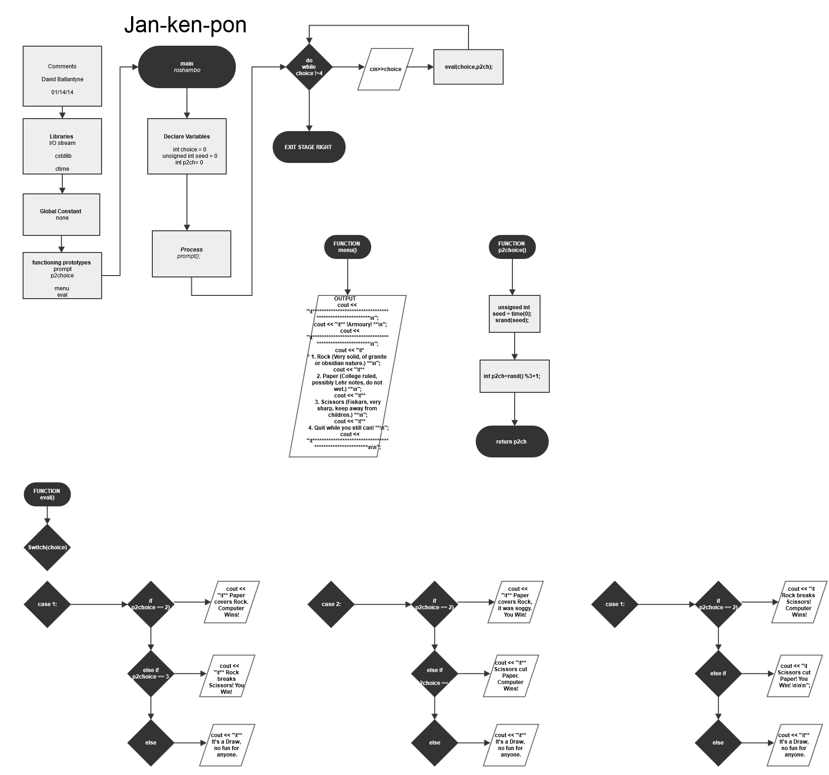

*(note jpg included with project folder)*

***Pseudo Code:***

*Execution begins here*

*Player one default*

*Player two default*

*Display prompt()*

*Do*

*P2choice()*

*set random number seed*

*mod rand to return value 1, 2, or 3*

*return the value*

*Display choice options menu()*

*Input user choice*

*Run evaluation function eval()*

*Switch to user input choice*

*Determine if output is win loss or tie*

*While user input is not equal to 4*

*Exit Stage Right*

|  |  |  |  |  |
| --- | --- | --- | --- | --- |
| **Type** | **Name** | **Location** | **Description** |  |
| int | choice | main, eval(int,int) | Player 1's rock paper scissor option |  |
|  | p2ch | main, eval(int, int) | p2choice()'s return integer |  |
| unsigned | seed | p2choice() | an unsigned variable to set random number seed |  |
| int |  |  |  |  |

|  |  |  |  |  |
| --- | --- | --- | --- | --- |
| **Loop** | **Location** | **Purpose** | **Gaddis Chapter** |  |
| Switch | eval() Function | to determine user choice | Ch4, pgs. 202-209; |  |
| Do While | main | To exit or continue Game | Ch5, pgs. 242-246,262; |  |
| If | eval() Function | to determine Output | Ch4, pgs 154-165; |  |
| If/else | eval() Function | to determine Output | Ch4, pgs. 166-168,176-180; |  |
| else | eval() Function | to determine Output | Ch4, pgs.167,177-179; |  |

**Reference**  
1.textbook

2.cplusplus.com/forums